ARC 5259 - Movable Scheduling Dashboard.

This project can be installed from the ARC using one click install.

This project is a modification of the standard menu Shop Floor Control > File > Replace, Update and Reschedule Job Utility. It loads in all jobs an has many additional columns and features.

For a user to have full access to the scheduling abilities, they must be in the EDITWO security group. Security groups can be added/maintained in System Support > File > User Security Maintenance or System Support > File > Group Security Maintenance. If the user is not in this group they will not be able to move or reschedule jobs. They can still modify and save the notes columns.

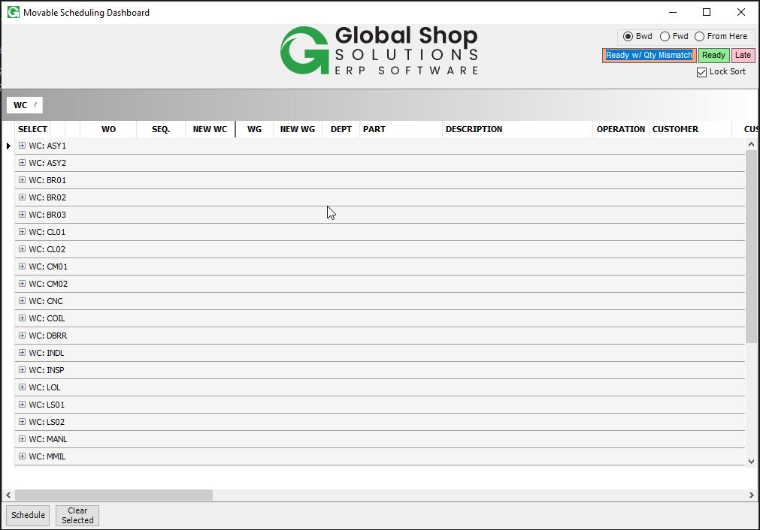

When the dashboard loads in it will be grouped by work center. The columns can be moved, removed, and resized like standard dashboard. The sort / grouping cannot be modified unless the “Lock Sort” checkbox in the top right is unchecked.

By right clicking the grid you can refresh, export to Excel, reset the formatting, or create a new work order.

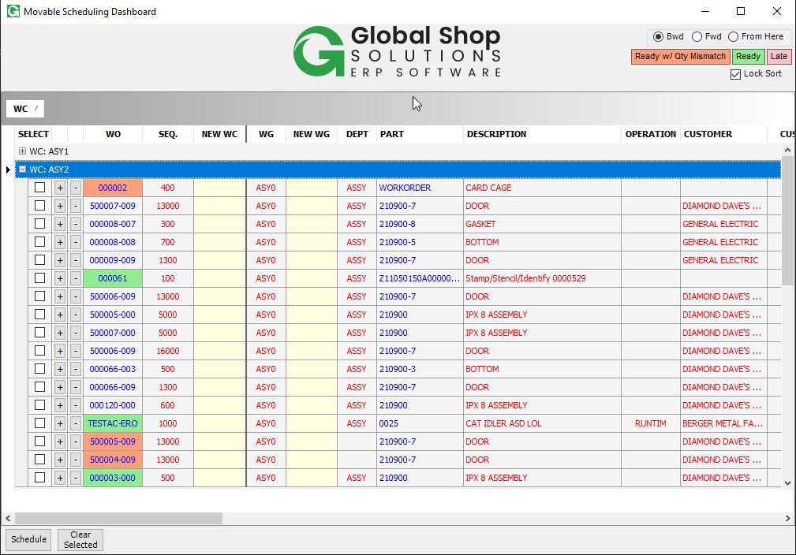

# Moving Rows:

Jobs can be moved by clicking the + or – button, or by manually modifying the sort column. The sort column loads in steps of 10 so that jobs can easily be moved between each other.

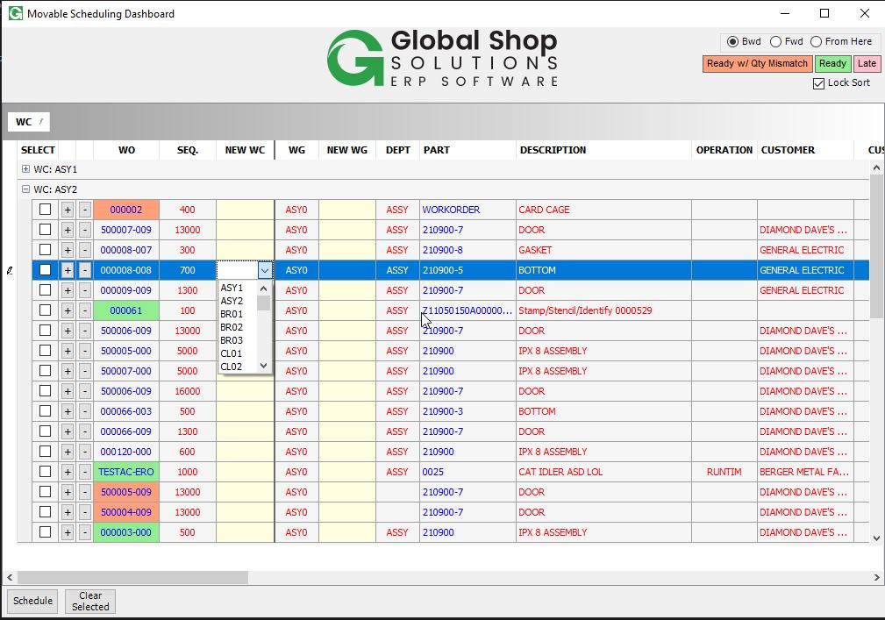

# Scheduling:

To reschedule a job to a new WC/WG, select one from the drop downs in the New WC or New WG column. The selected column will then be checked and the job will be scheduled when the Schedule button is clicked.

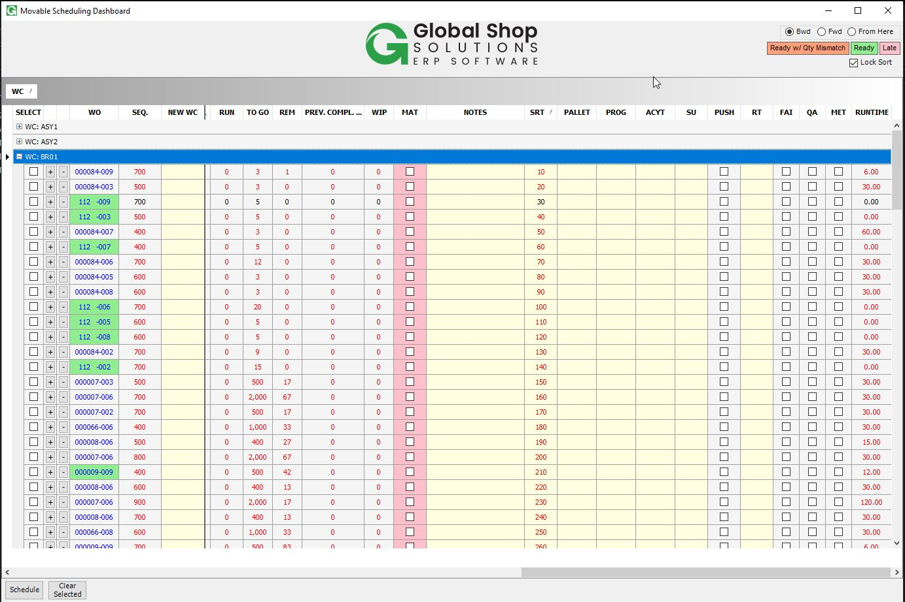

# Columns:

The custom columns like Notes, Pallet, Prog, ACYT, and SU are saved when they are modified. The MAT column is checked if the/a material sequence on the job has been completed. ESTCT is estimated seconds per piece. WIP is the pieces claimed on the previous sequence minus the pieces claimed on this sequence. RUN is units complete. REM is the TO GO / RUNTIME. PUSH will be checked if the RUNTIM operation on the job is closed. FAI, MET, and QA will be checked if the tasks on those work orders with FAI, MET, or QA in their name respectively are signed off.

Clicking the work order number will take you to Shop Floor Control > View > Work Orders for that work order. The part will take you to Supply and Demand for that part.

Clicking the PUSH column will bring up a menu to claim pieces on the RUNTIM step of the work order.

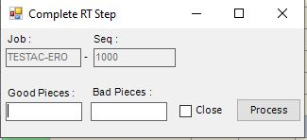

Clicking the FAI, QA, or MET columns will bring up the task sign off menu if that task exists on that job.

There are some extra rules for what shows up on the dashboard. No sequence with the operation SETUP will show up. However, if the RUNTIM step is rescheduled, the associated SETUP step will be rescheduled as well.

For sequences with the WIP, WIPFG, INSPEC, or OUT operations, these will only show if the WIP column is not 0.

The text on the row will go red if the current date is greater than the original due date of the job.

# Auto Export:

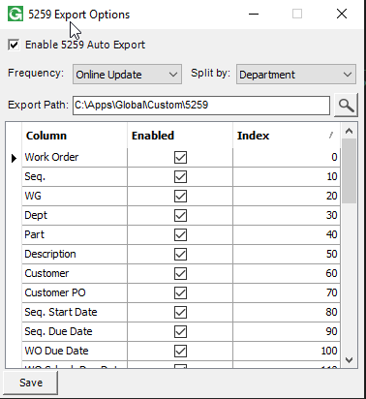

The auto export ability can be set up in. Shop Floor Control > Admin > Scheduling Dashboard Auto Export [5259]. When this is enabled, the program will run at the interval specified in the Frequency drop down and export the dashboard to the given path. If a split by option is selected, the export will be divided into different files based on the option chosen. The columns to export and order to show them in can be set in the column grid.

A log file of the auto export will be created in Global\Custom\5259, logging the export and any issues it encounters.

For the auto export to run properly, the Auto Export script must be attached to the 38130 post online update hook.

# User Views:

For this dashboard, you can create user views based on security groups with the menu Shop Floor Control > Admin > Scheduling Dashboard User View Maintenance [5259]. Here you can choose what columns a group sees and what order they are in, as well as what department the group sees. When a user view is found for a user, they will be unable to move the columns. Groups marked as admin groups will be able to see a drop down list of all user views on the dashboard and switch between them.

